
EXAMINATION (SECOND TERM)
2025/2026 ACADEMIC SESSION

JSS1
CODING

(Sectio

DURATION: 60 minutes MARCH, 2026.
GENERAL INSTRUCTIONS TO CANDIDATES

- This question paper is about a practical animation project.
- Answer all the question accordingly.
- Write the code (answers) on the script provided if you are not with laptop.
- Those with laptop should build the project with VScode and submit their folders.

Name

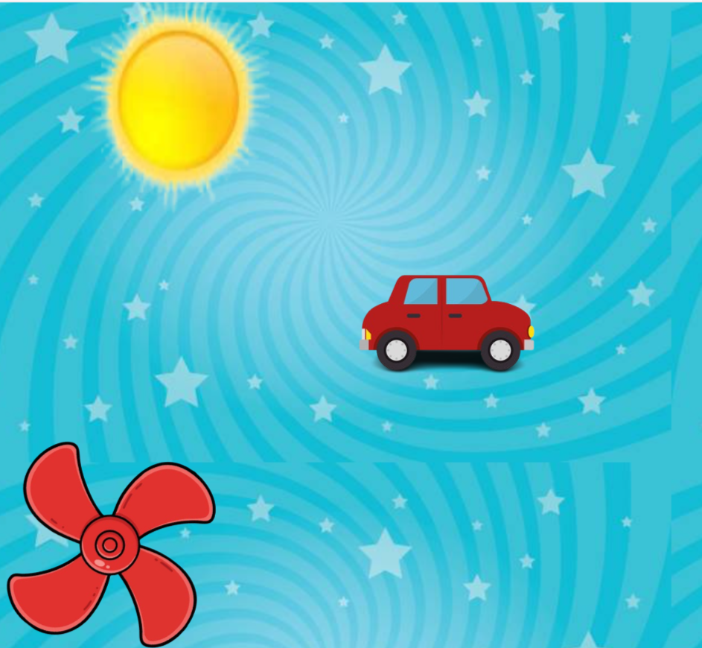

Project setup (those with laptop)
1. Create a folder on your desktop
e.g Exams John Smith Diamond. Change John Smith to your name.
2. Open your code editor(vscode) and select the folder
3. Create two files, HTML and CSS files
4. Generate the boiler plate
5. Link your CSS file in the HTML file
Project setup (those without laptop)
1. Write the correct file name for the HTML file
2. Write the correct file name for the CSS file
3. Fill in the correct syntax for the HTML boiler plate
4. Write the code to Link your CSS file in the HTML file

FILE 1
File name:

OUTPUT — The image at top is what your page should look like in the browser:
Three images displayed on the page, one after the other.
Each image should be animating on its own —
the sun image should scale up and down, the car image should move from left to right and the fan image should be rotating. The title of your project is Image Animations

Complete the HTML boilerplate and write your image code in the empty lines inside <body>:

<!DOCTYPE _______________>
<html lang=" _______________">
<head>
<meta charset="UTF-8">
<title>________________________</title>
<link rel="stylesheet" href="_______________">
</head>
<body>

</body>
</html>

FILE 2
File name:

OUTPUT — This is what your CSS must do:
.sun — should have animation name of scaleupdown using (translateX); height--200px, width-->350px
.car — should have animation name of moveleft using (rotateZ); height--200px,
width-->200px
.fan — should have animation name of spin using (scale); height--200px, width-->250px

Fill in ALL the blanks — property names and values:

@keyframes _______________ {
from {
transform: _________________________ ;
}
to {
transform: _________________________ ;
}
}

@keyframes _______________ {
_______ {
__________: _________________________ ;
}
_________ {
__________ : _________________________ ;
}
}

@keyframes _______________ {
_______ {
__________: _________________________ ;
}
_________ {
__________ : _________________________ ;
}
}

.sun {
display: _________________________ ;
width: _________________________ ;
height: _________________________ ;
_______________________: _______________________ ;
_______________________: _______________________ ;
_______________________: _______________________ ;
_______________________: _______________________ ;
_______________________: _______________________ ;
}

.car {
display: _________________________ ;
width: _________________________ ;
height: _________________________ ;
_______________________: _______________________ ;
_______________________: _______________________ ;
_______________________: _______________________ ;
_______________________: _______________________ ;
_______________________: _______________________ ;
}

.fan {
display: _________________________ ;
width: _________________________ ;
height: _________________________ ;
_______________________: _______________________ ;
_______________________: _______________________ ;
_______________________: _______________________ ;
_______________________: _______________________ ;
_______________________: _______________________ ;
}

— Good Luck! —

